Exp 5 : Using Raptor – Draw and validate a flowchart for a given string of lower case English alphabets. One can choose any two characters in the string and replace all the occurrences of the first character with the second character and replace all the occurrences of the second character with the first character. Using Raptor draw and validate the flowchart smallest string that can be obtained by doing this operation at most once.
Step 1: Open RAPTOR
Open RAPTOR.
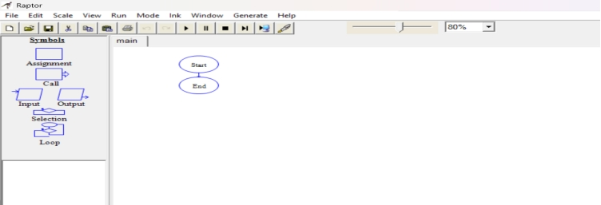

Step 2: Input String
Insert Input symbol.
Prompt: "Enter a string"
Variable: str
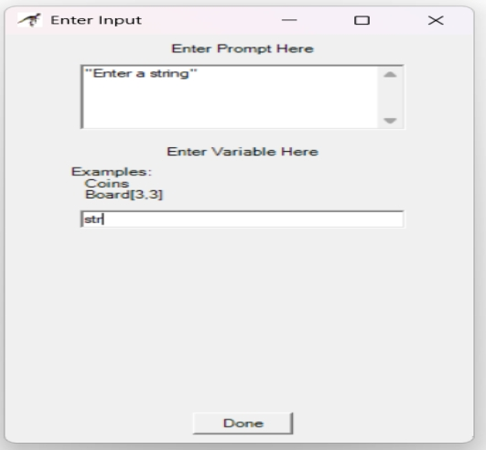
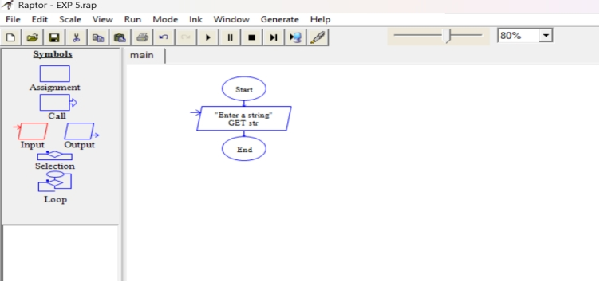

Step 3: Initialize Variables
Insert Assignment symbol.
Set: found
To: false

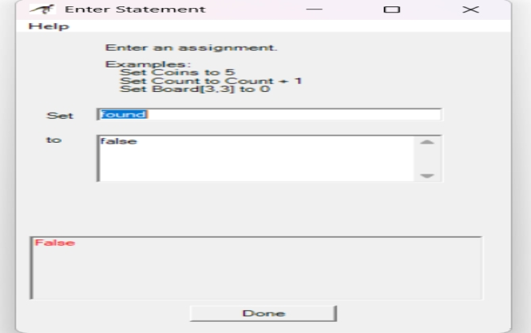
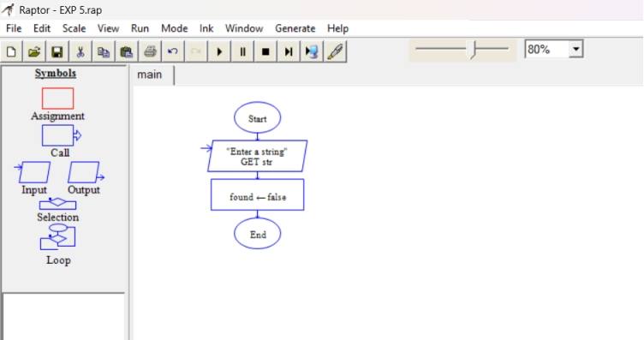
Step 4: Outer Loop
Insert Loop symbol.
Condition:
i <- 1 to Length_Of(str)
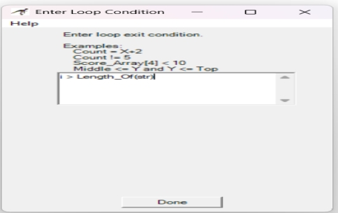
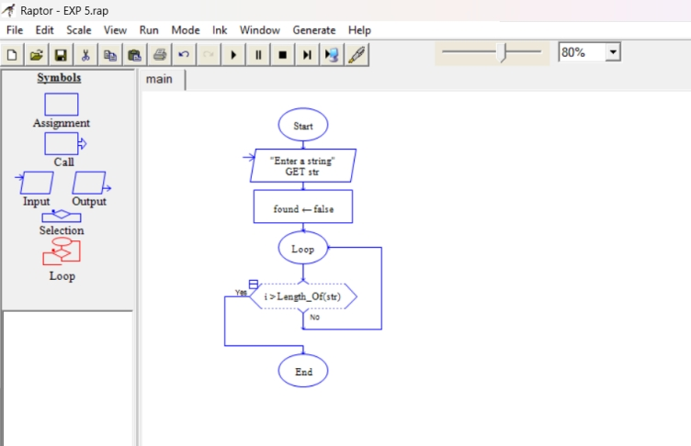

Step 5: Inner Loop
Inside the first loop, add another Loop.
Condition:
j <- i+1 to Length_Of(str)

Step 6: Decision Symbol
Condition:
str[j] < str[i]
If True:
Assignment
c1 <- str[i]
c2 <- str[j]
found <- true
Exit loops.

Step 7: Replace Characters
If found = true
Add loop:
k <- 1 to Length_Of(str)
Inside loop:
Decision 1
str[k] = c1
True:
str[k] <- c2
Decision 2
str[k] = c2
True:
str[k] <- c1
Step 8: Output Result
Insert Output symbol.
"Lexicographically Smallest String = "
Insert another Output: Str

